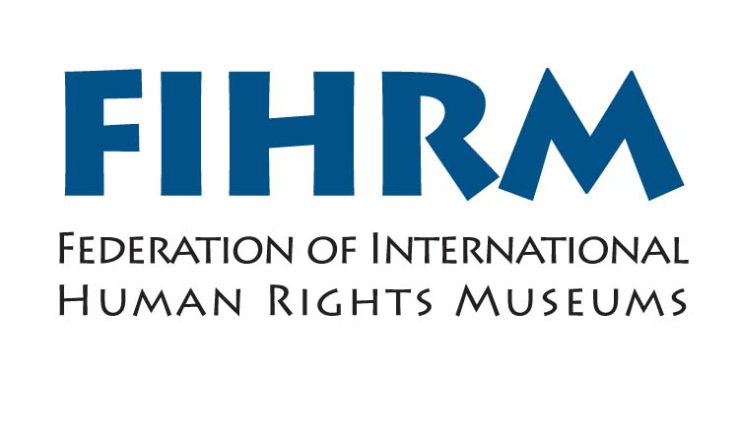

Invitation and call for papers

Museums and Human Rights

8-10 October 2012

International Slavery Museum
Liverpool, UK

Call for Papers and Proposals

We would like to invite you to submit your expressions of interest to attend and or speak at the conference under the following theme:

Museums and Human Rights

It is 5 years since the opening of the International Slavery Museum. In that time, the view has become more widespread that museums should play an active role in fighting for human rights, and there are now many museums around the world that are active in this field.

In this conference we want to consider the ways in which museums have made progress, or not.

We wish to look at recent and current examples of progressive work, in terms of combating gender and ethnic inequalities, discrimination and other human rights abuses.

Proposals

You can submit proposals for case studies, research papers, workshops and poster sessions under any of the above themes. Proposals should be around 300 words and in addition you are asked to submit a short biography of about 200 words.

All papers must be in English.

The deadline is 30 June 2012.

Bursary Scheme

FIHRM will offer a number of bursaries to cover travel and accommodation for those who would not be able to attend otherwise. For more details on the bursary scheme, please visit the website at www.fihrm.org

Fees
There is no registration fee for attending.

Further information

For further details on the conference, please visit the FIHRM website at www.fihrm.org

If you have any further queries, please contact Françoise McClafferty at fihrm@liverpoolmuseums.org.uk

Spread the word
Please pass on this invitation to any other colleagues and organisations who you think may be interested in this initiative.

