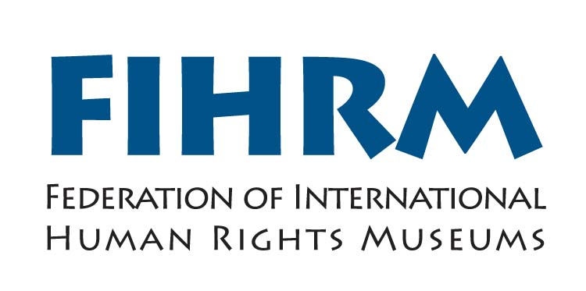

Third International Conference

Museums and human rights

8-10 October 2012, International Slavery Museum, Liverpool, United Kingdom

BURSARY APPLICATION FORM

The Federation of International Human Rights Museums led by National Museums Liverpool’s International Slavery Museums is offering a limited number of bursaries to attend its annual conference from 8-10 October 2012 in Liverpool in the UK.

You can apply for two types of bursary:

- FULL BURSARY: covers full travel and accommodation and subsistence costs.

- PARTIAL BURSARY: up to £500 towards flight and accommodation

Please note that you if you are not successful in your application for a full bursary, you may still be considered for a partial bursary.

Criteria:

- Applicants must be qualified museum professionals and must be currently employed in a museum or related institution.

- Applicants must provide a proposal for consideration under one of the themes of the conference. See below for details on conference themes.

- Applicants must provide a post-conference report to FIHRM and demonstrate how they will use the knowledge gained at the conference back in the museum or institution that they work for.

All documents should be sent in an electronic format. If you are unable to send an electronic copy, please see postal address at the end of the application form.

The deadline for applying is 30 June 2012. Submissions received after this date may not be considered.

Selection process
Applications will be evaluated by the FIHRM Selection Committee and applicants will be informed of the committee’s decision by 10 July. Within 10 days of notification of approval of a bursary, applicants must confirm their acceptance. (no later than 20 July 2012)

If you wish to apply, please fill out this application form (it can be filled out directly in the Word Doc format) and submit the required information to the FIHRM Coordinator, Françoise McClafferty at fihrm@liverpoolmuseums.org.uk.

Full name:

Country of provenance:

Full address:

Telephone number:

Fax number:

E-mail

This application is for:

FULL BURSARY

PARTIAL BURSARY (maximum £500GBP)

(1) PROFESSIONAL QUALIFICATIONS AND EXPERIENCE
Up-to-date curriculum vitae indicating training, work experience, publications and current work responsibilities (maximum of 250 words)

(2) NAME, POSITION AND CONTACT INFORMATION OF ONE REFEREE

(3) BENEFITS OF ATTENDANCE
Please answer the following questions :
- What are the most important reasons why you want to participate in conference?

- Have you already submitted a proposal for a paper?

If yes, please insert it here again.

If no, please submit a proposal in no more than 300 words under one of the themes of the conference. Details on conference themes can be found at www.fihrm.org and at the end of this application form.

- How do you plan to disseminate the information and knowledge gained at the conference upon your return to your home country?

- Have you ever received a grant to attend similar international conferences?
If yes, when? And which ones?

- Are you a member of other professional bodies/associations?

(4) FINANCIAL ESTIMATE

In order to be eligible for the grant, you MUST indicate below the estimated travel costs from your home city to the UK.

Economy air fare from _________________________ (city/country of origin) to UK:

Please indicate estimated amount in US Dollars/EUR/GBP: _____________________

Please indicate transfer requirements in your country of origin:

_______________________________________________________________________

Bursary Terms and Conditions:
- Bursary recipients are expected to organise their own visa.
If you require an invitation letter for your visa please tick here .
- Bursary recipients are expected to cover expenses for the visa and any insurance required.
- In the case that you are no longer able to accept the bursary, you must notify FIHRM at least 15 days before the start of the conference.
- Bursary recipients are required to complete a bursary report of no more than 500 words within 30 days of the end of the conference.

FULL BURSARY ONLY
- FIHRM will pay for one economy return flight from your country of origin to the UK.
- FIHRM will arrange transfer to Liverpool from your airport of arrival in the UK.
- Travel dates must take place no more than 15 days prior to or after the conference. If you require alternative or additional travel arrangements, FIHRM will only fund the equivalent cost of an economy flight from your country of origin to the UK. Any additional travel requirements must be made by the applicants themselves.
- Hotel bookings for the duration of the conference will be made by FIHRM.
- Subsistence for the duration of the conference will be handed to you on the first day of the conference (10 October 2011).

The deadline for applying is 30 June 2012. Submissions received after this date may not be considered. All documents should be sent in an electronic format. If you are unable to send an electronic copy, please see postal address at the end of the application form.
Contact: Françoise McClafferty, FIHRM Coordinator

E-mail: fihrm@liverpoolmuseums.org.uk

Postal address: National Museums Liverpool
World Museum Liverpool
William Brown Street
Liverpool L3 8EN
UK
Europe

